Cloud function: ajay-10

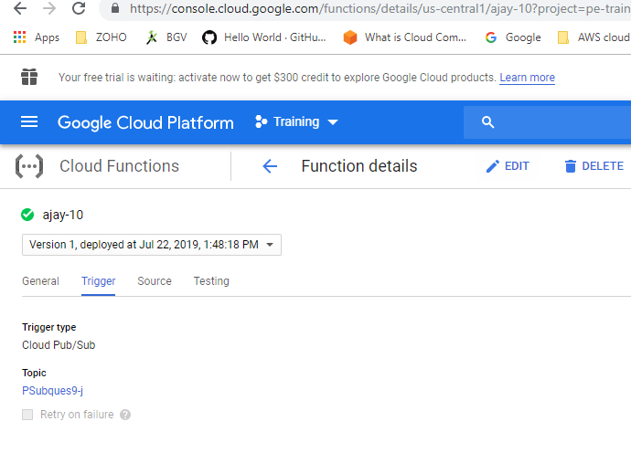

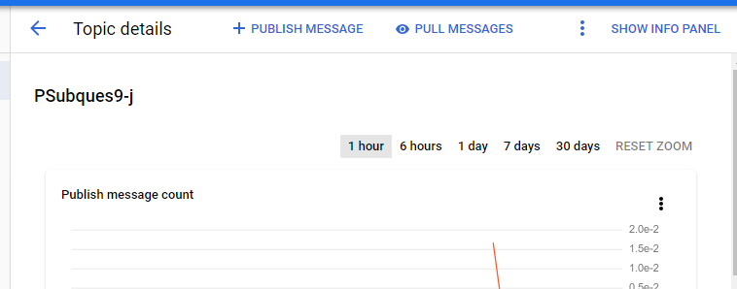

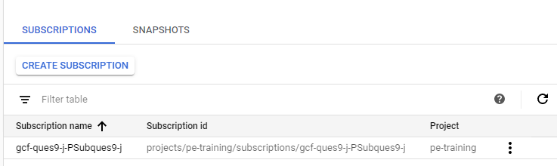

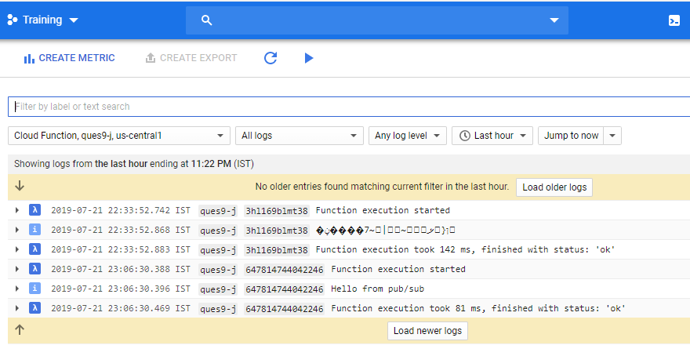

Bigquery : ques9_DB_j ,

Code:

import base64
from google.cloud import bigquery

def hello_pubsub(event, context):
pubsub_msg = str(base64.b64decode(event['data']).decode('utf-8')) # pubsub_msg = "bucketname objectpath"
pubsub_msglist = pubsub_msg.split(' ') # pubsub_msglist = ['bucketname', 'objectpath']
bucketname = pubsub_msglist[0] # storing the buckename in a variable
objectpath = pubsub_msglist[1] # storing the objectpath in a variable

client = bigquery.Client()

dataset_ref = client.dataset('ques9_DB_j') # Creating a variable for dataset_ref = client.dataset(dataset_id)

# Specifying the Job configuration of BigQuery
job_config = bigquery.LoadJobConfig()

job_config.autodetect = True # Auto Detects the schema of the table to be created
job_config.source_format = bigquery.SourceFormat.NEWLINE_DELIMITED_JSON # source_format = JSON

uri = 'gs://{}/{}'.format(bucketname, objectpath) # JSON Object URI 'gs://{bucketname}/{objectpath}'
print("Uri : {}".format(uri))
load_job = client.load_table_from_uri(
uri, # URI from which the JSON should data source should be taken
dataset_ref.table("ajay_table"), # Table name on to which the data should load
location="US", # Location must match that of the destination dataset.
job_config=job_config # giving the specified job_config
)

print("Starting job {}".format(load_job.job_id))
load_job.result() # Waits for table load to complete.
print("Job finished.")

destination_table = client.get_table(dataset_ref.table("Q9Table")) # Getting the table object with table name
print("Loaded {} rows.".format(destination_table.num_rows)) # Printing the table rows of the table

